Report Of
ADH ID GENERATION SOFTWARE
By ADH Enterprises

Submitted To
School of Computer Science and Engineering
IILM University, Greater Noida, U.P.

In partial fulfilment of the requirement of degree of
B.Tech CSE

By
Roll Number of Student: 25SCS1003005431
Name of Student: Mohd Hunain Zafar
Year / Semester: 2nd Year, 3rd Semester
Batch: 2026–27

CANDIDATE'S DECLARATION
I, Mohd Hunain Zafar, hereby declare that the internship report titled “ADH ID Generation Software” has been completed by me as a part of my internship and in partial fulfilment of the requirements for the award of the degree of Bachelor of Technology in Computer Science and Engineering.

I am currently pursuing B.Tech in Computer Science and Engineering and am in my 2nd Year, 3rd Semester. During my internship, I worked with the team on the planning and development of the ADH ID Generation Software.

My contribution mainly included participating in the initial ideation and planning of the product, helping with parts of the front-end, contributing to the layout and working structure of the product, and assisting with database management.
The information presented in this report is based on my work, learning, and experience during the internship. I confirm that this report has been prepared for academic submission and has not been submitted to any other institution for the award of any degree or diploma.

ACKNOWLEDGEMENT
I would like to sincerely thank everyone who supported and guided me during my internship.
This internship gave me an opportunity to experience how a software product is planned and developed in a practical environment. Working on the ADH ID Generation Software helped me understand that creating a product is not only about coding, but also about understanding the idea, planning the structure, deciding how it should work, and improving it through discussion and development.

I am especially thankful to my mentors and team members for involving me in the product discussions and development process. Their guidance helped me contribute to the initial ideation and planning of the product, work on parts of the front-end, understand the layout and workflow of the application, and gain practical exposure to database management.

I am also grateful to the School of Computer Science and Engineering, IILM University, for providing me with the opportunity to undertake this internship and gain practical experience beyond the classroom.

Finally, I would like to thank my parents, friends, and everyone who encouraged and supported me throughout the internship.

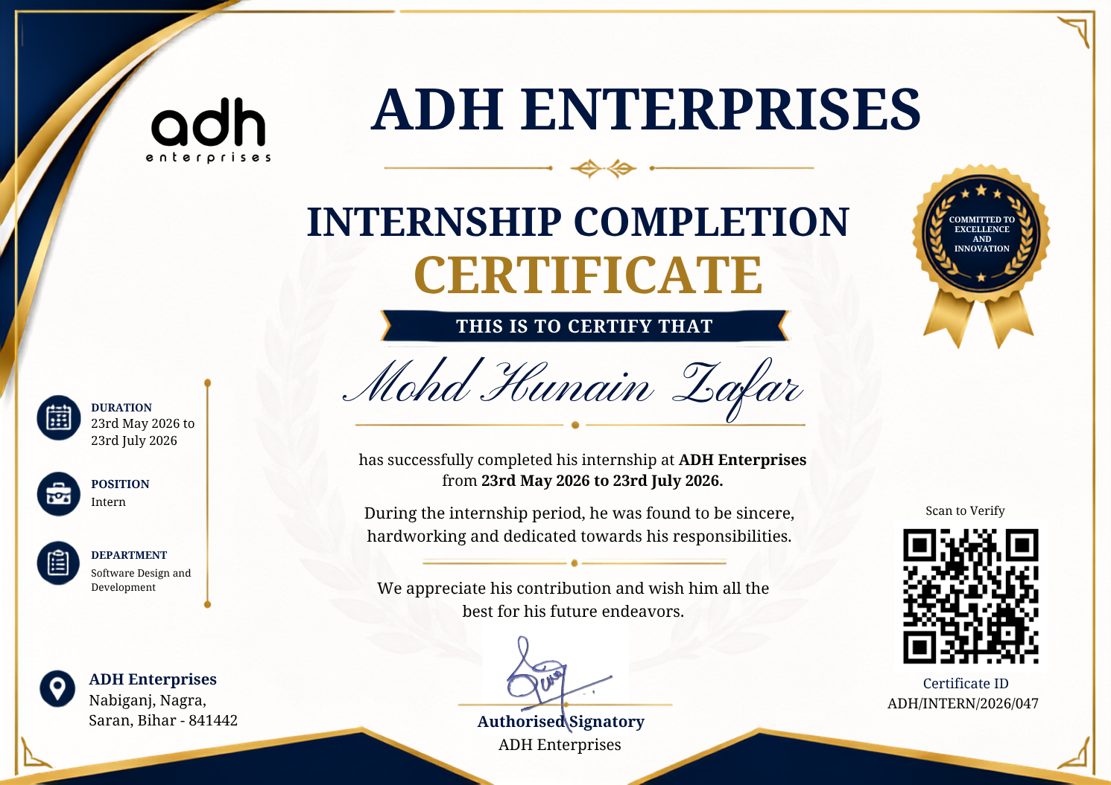
INTERNSHIP COMPLETION CERTIFICATE

Certificate Holder: Mohd Hunain Zafar
Organization: ADH Enterprises
Internship Period: 23rd May 2026 to 23rd July 2026

PROJECT DESCRIPTION
4.1 INTRODUCTION
During my internship, I got the opportunity to work on a software product called ADH ID Generation Software. The main idea behind the product was to make the process of managing information and generating identification cards more organized and convenient.
My involvement started from the early stage of the product, where I participated in discussions about the idea, planning, and the way the product should be structured. This gave me an opportunity to understand how a product is shaped before and during its development.
I also contributed to parts of the front-end development and helped in discussing the layout and working flow of the application. Along with this, I assisted with the database management side of the product.
The project helped me understand how different parts of a software product need to work together and how planning and usability are important along with development.

4.2 ORGANIZATION PROFILE
ADH Enterprises is an organization working in the areas of printing, designing, and digital solutions. During my internship, I got the opportunity to work with the team on the ADH ID Generation Software.
The internship gave me practical exposure to a real working environment where ideas were discussed, planned, developed, and refined. It also helped me understand how a software product can be developed according to practical requirements rather than only following a classroom-based problem statement.
Being involved in the product from an early stage was particularly useful because I was able to see how the initial idea, layout, workflow, interface, and data management were connected.

4.3 PROBLEM STATEMENT
Creating and managing ID cards can become difficult when a large number of records have to be handled. Information has to be organized properly, the layout has to remain consistent, and changes or corrections may have to be managed before the final ID cards are prepared.
When such work is handled manually, it can require considerable time and may also result in repeated work or inconsistencies.
The ADH ID Generation Software was planned to provide a more organized way of handling this process. The main idea was to bring the required activities into a single structured product and make the overall workflow easier to manage.

4.4 PROJECT OBJECTIVES
- To develop an organized software solution for ID generation.
- To plan the overall idea and structure of the product before development.
- To create a simple and understandable user interface.
- To plan suitable layouts for different parts of the application.
- To establish a clear and logical working flow for the product.
- To organize the information required by the application.
- To support the product through proper database management.
- To create a product structure that can be improved in the future.
My personal contribution was mainly focused on product ideation and planning, front-end work, layout and workflow discussions, and database management.

4.5 SCOPE OF THE PROJECT
The scope of the ADH ID Generation Software is to provide a structured way of managing the ID generation process.
The project mainly covers:
- Planning and organizing the overall product.
- Providing a user-friendly front-end interface.
- Designing and discussing the layout of the application.
- Planning the workflow through which users interact with the product.
- Organizing and managing the information required by the system.
- Supporting the database used by the application.
- Providing a base that can be extended according to future requirements.
The product can be improved further as new requirements and use cases are identified.

4.6 TECHNOLOGIES AND TOOLS USED
The project involved different software development tools and technologies. My work was mainly connected with the practical areas of front-end development and database management.
The major areas in which I gained experience were:
- Front-End Development – helping create and improve the user-facing parts of the product.
- Layout and Interface Work – helping decide how different sections should be arranged and presented.
- Database Management – assisting with the organization and maintenance of the data used by the product.
- Development and Testing – working with the team while different parts of the product were developed and refined.
The internship helped me understand how these different areas come together to form a complete software product.

4.7 SYSTEM ARCHITECTURE
The overall product structure was planned by dividing the work into connected areas. At a simple level, the product can be understood through the following flow:
PRODUCT IDEA
↓
PLANNING & STRUCTURE
↓
LAYOUT & USER INTERFACE
↓
USER WORKFLOW
↓
DATA MANAGEMENT
↓
ID GENERATION

My contribution was mainly in helping think through the product idea and its structure, discussing the layout and workflow, contributing to the front-end, and assisting with the organization and management of the required data.
The purpose of this structure was to keep the product understandable and organized while allowing its different parts to work together.

4.8 METHODOLOGY
The product was developed gradually, starting from the basic idea and moving towards planning, layout, development, and data management. My involvement can broadly be described through the following stages:
1. Product Ideation
The initial stage involved understanding the purpose of the product and discussing what it should achieve. I participated in these discussions and helped in thinking about how the product could be made useful and simple for its intended users.
2. Planning and Product Structure
After the basic idea was understood, the overall structure and working of the product were discussed. I contributed to discussions about how different parts should be connected and how the overall process should be organized.
3. Layout and Workflow
I helped in the ideation of the layout and work structure of the product. This included discussing how different sections should be arranged, how the user should move through the application, and how the overall workflow could remain clear and easy to understand.
4. Front-End Contribution
I also helped with parts of the front-end development. My work involved contributing to the user-facing portions of the product and refining the interface based on the planned layout and workflow. This helped me understand how product ideas are converted into an actual interface.
5. Database Management
I also assisted with the back-end side of the product, mainly in the area of database management. This gave me practical experience in understanding how the information used by a software product is organized and maintained.

4.9 EXPECTED OUTCOMES
The main expected outcome of the project was to create an organized and easy-to-use software product for managing the ID generation process. The product was intended to make the overall process more structured and reduce unnecessary manual effort.
From my internship perspective, the project helped me gain practical understanding in the following areas:
- Understanding how a software product is initially conceptualized.
- Planning the basic structure of a product before development.
- Understanding how layout and workflow affect the user experience.
- Contributing to front-end development.
- Understanding how different parts of a product work together.
- Gaining practical exposure to database management.
- Working collaboratively while developing a real software product.
One of the most important things I learned was that software development begins with understanding the problem and planning the solution. Coding is an important part of development, but a clear idea, proper structure, good layout, and a logical workflow are equally important.

4.10 CERTIFICATES OF COMPLETION AND OTHER COMMUNICATION
The Internship Completion Certificate issued by ADH Enterprises is attached with this report.
Any relevant internship-related communication or supporting documents may also be attached in this section, if required.

BIBLIOGRAPHY / REFERENCES
- Documentation and learning resources referred to during the development of the ADH ID Generation Software.
2. Internal project discussions and guidance received during the internship.
3. Development references consulted during front-end development and database
management.

